"Enhancing Instant Noodles Supply Chain Efficiency: A Data-Driven Approach"



Overview

Project Background:

* A Fast Moving Consumer Goods (FMCG) company ventured into the instant noodles business two years ago.
* The company's management has identified a significant issue of demand-supply mismatch.
* This mismatch results in increased inventory costs and overall financial losses.
* The project aims to optimize supply quantities across all warehouses nationwide.

Goals and Objectives

Project Goals:

* Optimize supply chain management to reduce inventory costs and improve efficiency.
* Address demand-supply mismatches to enhance overall profitability.

Data Dictionary

|  |  |
| --- | --- |
|  |  |
| Variable | Description |
|  |  |
| Ware_house_ID | Unique Warehouse id where product is  prepared for dispatch.  dtype: Object |
|  |  |
| WH_Manager_ID | Manager Id present in the warehouse  dtype: Object |
|  |  |
| zone | Zone of the Warehouse, dtype: String |
|  |  |
| WH_regional_zone | Regional Zone of the warehouse, dtype:  Object |
|  |  |
| num_refill_req_l3m | Refilling request received by the warehouse in  the last 3 months, dtype: integer. |
|  |  |
| transport_issue_l1y | No. of transport issued for warehouse in last 1  year, dtype: integer. |
|  |  |
| Competitor_in_mkt | No. of competitors in the market, dtype:  integer. |
|  |  |
| retail_shop_num | Number of retail shops who sell noodles  produced by the warehouse, dtype: integer. |
|  |  |
| wh_owner_type | The warehouse is owned by the company or  it is on rent, dtype: String |
|  |  |
| distributor_num | No. of distributor who works between  warehouse and retail shops, dtype: integer. |
|  |  |
| flood_impacted | Is the warehouse in a flood impacted area or  not, dtype: integer |
|  |  |
| flood_proof | Flood_proof: Warehouse is having flood proof  indicator, dtype: integer. |
|  |  |
| electric_supply | Does the warehouse have proper electric  supply along with some power backup, dtype:  integer. |
|  |  |
| dist_from_hub | distance from the warehouse to production  hub, dtype: integer |
|  |  |
| workers_num | no. workers in the warehouse, dtype: integer |
|  |  |
| wh_est_year | warehouse establishment year, dtype: integer. |
|  |  |
| storage_issue_reported_l3m | storage issues reported by the warehouse in  the last 3months |
|  |  |
| temp_reg_mach | warehouse having temperature regulating  machine indicator or not, dtype: integer. |
|  |  |
| approved_wh_govt_certificate | Type of approval warehouse having been  issued by government, dtype: Object |
|  |  |
| wh_breakdown_l3m | Number of times the warehouse faces the  breakdown in the last 3 months, dtype:  integer. |
|  |  |
| product_wg_ton | Product weight, dtype: integer |
|  |  |

This data dictionary provides essential information about each field in the dataset, helping you understand the dataset's structure and the role of each variable in the analysis.

Summary:

Our project aims to optimize instant noodles supply chain management in the FMCG industry. We will develop a data-driven regression model using historical data to predict ideal product shipment weights for each warehouse. By minimizing costs and improving efficiency, we seek to tackle demand-supply mismatches and enhance overall performance. Join us on this journey to redefine supply chain success with data-driven insights.

Hyperparameter tunning:

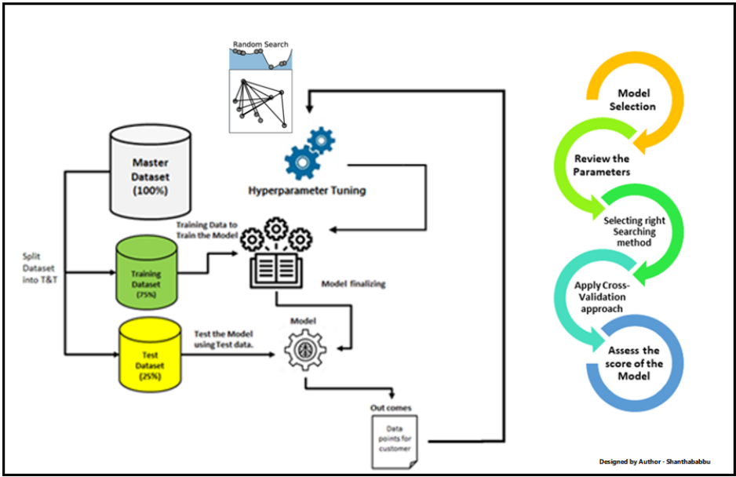

When you’re training machine learning models, each dataset and model needs a different set of hyperparameters, which are a kind of variable. The only way to determine these is through multiple experiments, where you pick a set of hyperparameters and run them through your model. This is called *hyperparameter tunning.* In essence, you're training your model sequentially with different sets of hyperparameters. This process can be manual, or you can pick one of several automated hyperparameter tuning methods.

Conclusion:

Exploring the data developed deep into its nuances. Unraveling of missing values, scrutinized distribution patterns, and painted a vivid picture of our dataset. The enchanting scatterplots unveiled relationships between variables, and the seaborn count plots revealed the distribution of categorical variables across different zones, types, and certifications. As we conducted correlation analysis, the heat map spoke volumes, showcasing how the storage reported during the last three months influenced sales shipment.

With our analytical compass steady, we navigated through model selection, guided by a plethora of performance metrics. In the end, the Gradient Boosting Regressor emerged victorious, its Adjusted R-squared of 0.986521 shimmering as a testament to its accuracy.

Recommendations:

1 Strategic Warehouse Placement: The analysis highlighted that most warehouses are situated in rural areas and the North zone. Leveraging this insight, supply chain managers can strategically allocate resources and streamline operations in these regions.

2 Storage Reporting Organization: The strong positive correlation between storage reported during the last three months and product shipment underscores the importance of timely and accurate storage reporting. Implementing efficient reporting mechanisms can lead to improved sales outcomes.

3 Government Certification Focus: As a significant number of warehouses possess government-approved certificates of 'C' type, focusing on obtaining and maintaining such certifications can enhance credibility and trustworthiness.

4 Enhanced Predictive Modeling: By embracing the Gradient Boosting Regressor model with hyperparameter tuning, supply chain managers can harness its predictive prowess to optimize sales and inventory management.